CURRICULUM VITAE 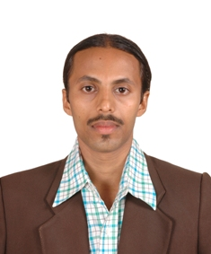
Name: Raymond Pascoal Pereira
Gender: Male
Date of Birth: 06/01/1982
Nationality: Indian

ACADEMIC QUALIFICATION
-Masters Degree in Fine Art (Printmaking),Kala Bhavana, Visva Bharati University,Santiniketan-West Bengal, India.2011
-Bachelors Degree in Fine Arts (Printmaking), Goa College of Art, Panjim-Goa, India.2008

WORKSHOPS
1-On “Solar Plate Etching”, At Kala Bhavana, Santiniketan,
West Bengal, India, December 2011. (By- Seraphina Martin, University of Sydney, Australia)
2-Niv International Artists Residency, at Niv Art Centre, New Delhi, India (July 20-Sept. 20, 2011)
3- On “Monoprints”, at Ruchika’s Art Gallery, Miramar, Goa, India (March-2008)

EXHIBITIONS
(UPCOMING)
1-Drawing & Print Show, From 18th -24th January 2013, at Art Gallery, Directorate of Art & Culture, Sanskruti Bhavan,Patto-Panjim, Goa , India .

(FEATURED SHOWS)
1-Niv International Artists Residency Exhibition,
at Niv Art Centre, New Delhi, India (16th September -16th October, 2011)
2-76th All India Exhibition of Art, Indian Academy of Fine Arts, Amritsar,Punjab-India, 2010
3-Kala Bhavana,Visva Bharati University,Santiniketan,
Annual Art Exhibition -2010, Held at The Academy Of Fine Arts, Kolkata, West Bengal,India.
4-“Coast To Coast”- By Students & Alumni, Of Goa College Of Art, Panjim, Goa-India, and The University of Connecticut, Storrs-Usa,
Held at The University of Connecticut Jorgensen Gallery, USA (1 Oct.-5 Dec.’08)

INTERESTS
Music, Reading, Sports –Football, Adventure Travelling, Trekking.

LANGUAGES KNOWN
English, Hindi, Konkani and Bengali.

contact details
Address: H.No.126, 2nd Ward Colva, Salcete-Goa, India.
Contact No: +91 9604212769 / 9002338689
Email: ray4art@rediffmail.com / raymond.pereira048@gmail.com

